**The following are tasks that need to be completed this term:**

1. Finish non-motorized telescope assembly.
   1. Drill holes into turntable and assemble uprights.

* 1. Drill holes and screw in horizontal struct piece.

* 1. Paint unfinished pieces

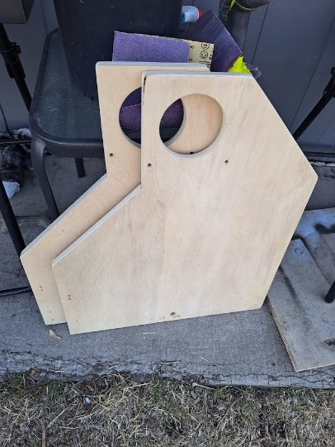

1. Create gearing system.
   1. Design and print large pulley gear.

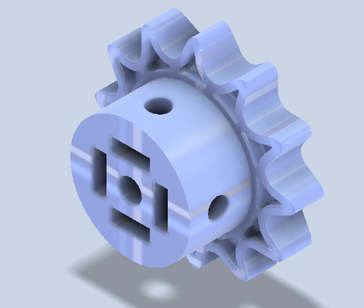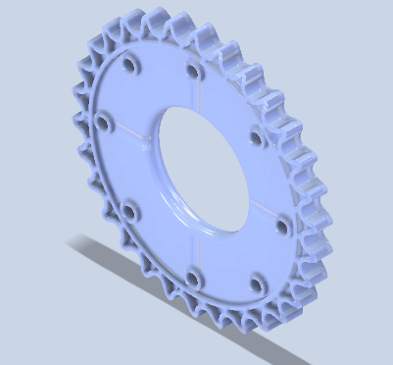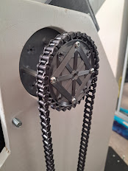

* 1. Order smaller gear and timing belts.

(you saw the timing belt in demo, now using chain I already had)

1. Connect power adapter to power supply.

(Saw in demo)

1. Connect power supply to stepper drivers.

(Saw in demo)

1. Connect level shifter for the 3.3V I/O of Raspberry Pi to 5V of the stepper motor driver.

(Completed, but later used 2222NPN transistors instead)

1. Develop software to drive motors.
   1. Develop software to drive 2 motors at once.

(see video)

<https://photos.google.com/photo/AF1QipPvImcMB4_67zJRhahv9zSW7swaBpVDf2k44Kmo>

1. Develop software to aim telescope.
   1. Find the math behind aiming 2 axis control in 3D geometric space.

“A rigorous algorithm for telescope pointing” – Patrick Wallace (2002)

* 1. Graphical user interface, text, application

     Description automatically generatedApply the math to the code for driving the motors.

1. Develop software to track a coordinate as the earth rotates.
   1. 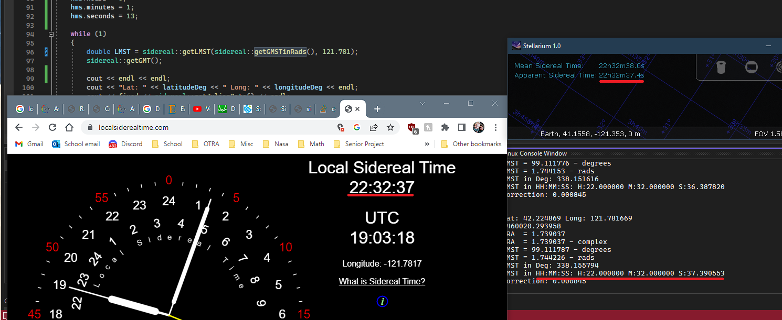Develop software for calculating sidereal time.
2. Graphical user interface, text, application, email

   Description automatically generatedCreate or purchase board and electronic housing.

**Signed:**

